NAME

**Eastern Goldfields College**

**Mathematics Methods U3&4 Test 2 – 2018**

**Calculator Free**

Reading Time: 2 minutes

Working Time: 30 minutes Marks: 29

**Question 1 (10 marks)**

Determine the following indefinite integrals

(a)  (2 marks)

(b)  (2 marks)

(c)  (2 marks

(d) $\int{\frac{6}{\sqrt{e^{3x}}}}dx$ (2 marks)

(e)  (2 marks)

**Question 2 (6 marks)**

Determine the following

(a)  (2 marks)

(b)  (2 marks)

(c)  (2 marks)

**Question 3 (5 marks)**

(a) Determine $\frac{d}{dx}$ $\left(2x\sin\left(3x\right)\right)$. (2 marks)

(b) Use your answer from (b) to determine $\int{6x\cos{(3x)}}dx$. (3 marks)

**Question 4 (5 marks)**

The graph below shows the curve $y=$ $\frac{180}{{\left(2x+5\right)}^{2}}$ and the line $x=5$.

Determine the area of the shaded region, enclosed by the $x-$ axis, the $y-$ axis, the line $x=5$ and the curve.

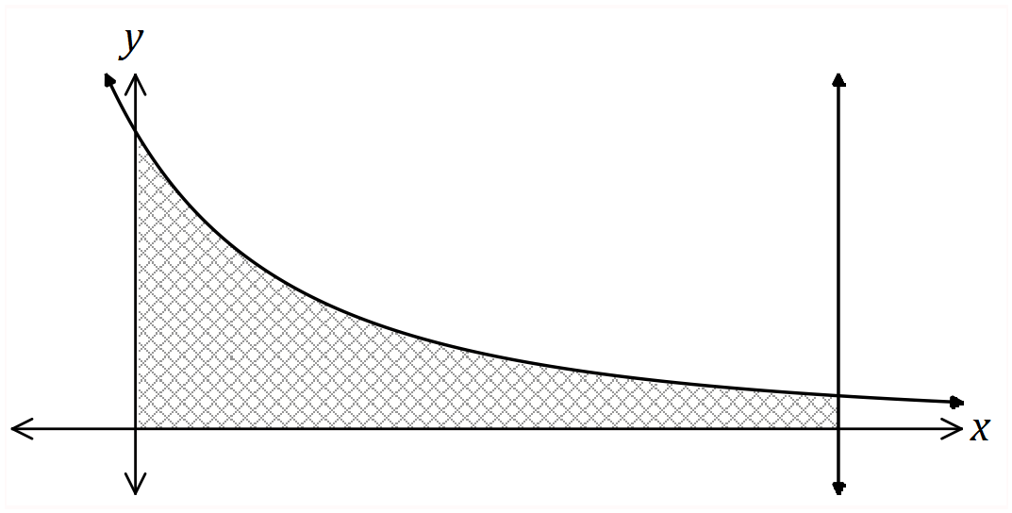

**Question 5 (3 marks)**

Given  , determine .

NAME

**Eastern Goldfields College**

**Mathematics Methods U3&4 Test 2 – 2018**

**Calculator Assumed**

Reading Time: 2 minutes

Working Time: 37 minutes Marks: 36

**Question 6 (4 marks)**

The instantaneous rate with which the concentration C, mg/kL of a chemical compound in a river system, changes with respect to time, t weeks, is modelled by

$\frac{dC}{dt}=\frac{1}{{(t+0.5)}^{2}}-2t$ for *t*≥0.

The initial concentration was 9.5 mg/kL

1. Find an expression for the concentration of the chemical in the river. (2 marks)
2. Find the net change in concentration during the first two weeks. (1 mark)
3. Find the net change in concentration during the fifth week. (1 mark)

**Question 7 (7 marks)**

The graphs of the functions $f$ and $g$ are shown below, intersecting at the points $(b, c)$ and $(d, 0)$.

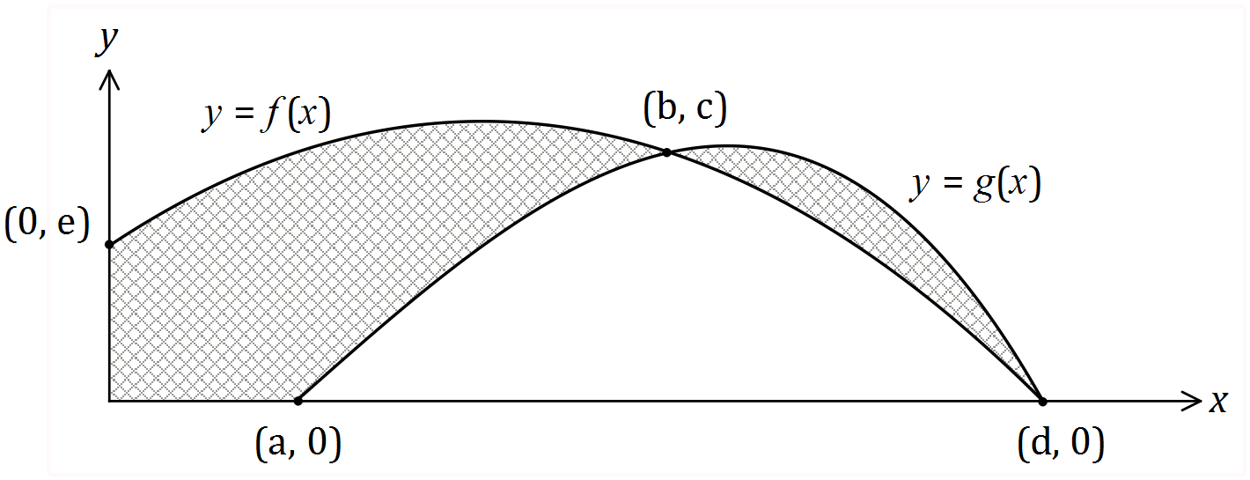

(a) Using definite integrals, write an expression for the area of the shaded region. (3 marks)

(b) Evaluate the area when $f\left(x\right)=15+12x-3x^{2}$ and $g\left(x\right)=-x^{3}+3x^{2}+13x-15$.

(4 marks)

**Question 8 (8 marks)**

The speed, in metres per second, of a car approaching a stop sign is shown in the graph below and can be modelled by the equation $v\left(t\right)=6\left(1+\cos\left(0.25t\right)+\sin^{2}\left(0.25t\right)\right)$, where $t$ represents the time in seconds.

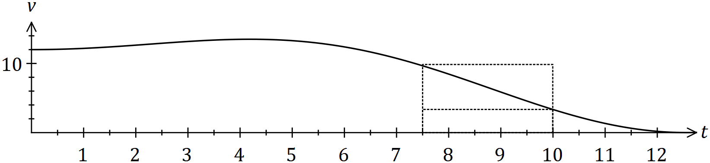

The area under the curve for any time interval represents the distance travelled by the car.

(a) Complete the table below, rounding to two decimal places. (2 marks)

|  |  |  |  |  |  |
| --- | --- | --- | --- | --- | --- |
| $$t$$ | $$0$$ | $$2.5$$ | $$5$$ | $$7.5$$ | $$10$$ |
| $$v(t)$$ |  |  |  |  | $$3.34$$ |

(b) Complete the following table and hence estimate the distance travelled by the car during the first ten seconds by calculating the mean of the sums of the inscribed areas and the circumscribed areas, using four rectangles of width 2.5 seconds.

*(The rectangles for the 7.5 to 10 second interval are shown on the graph.)* (5 marks)

|  |  |  |  |  |
| --- | --- | --- | --- | --- |
| Interval | $$0-2.5$$ | $$2.5-5$$ | $$5-7.5$$ | $$7.5-10$$ |
| Inscribed area |  |  |  | $$8.35$$ |
| Circumscribed area |  |  |  | $$24.15$$ |

(c) Suggest one change to the above procedure to improve the accuracy of the estimate.

(1 mark)

**Question 9 (9 marks)**

The graph of $y=f(x)$ is shown below. The areas between the curve and the $x-$ axis for regions $A$, $B$ and $C$ are $3$, $20$ and $12$ square units respectively.

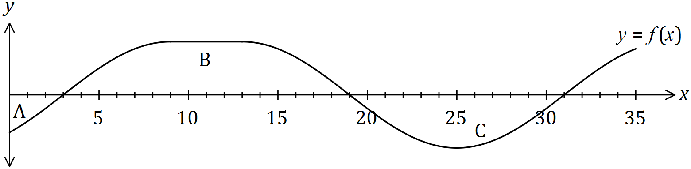

(a) Evaluate

(i) $\int_{0}^{31}{f(x)}dx$. (1 mark)

(ii) $\int_{19}^{0}{f(x)}dx$. (2 marks)

(iii) $\int_{3}^{31}{2-3f(x)}dx$. (3 marks)

It is also known that $A\left(31\right)=0$, where $A\left(x\right)=\int_{10}^{x}{f(t)}dt$.

(b) Evaluate

(i) $A(19)$. (1 mark)

(ii) $A(0)$. (2 marks)

**10. (8 marks - 6, 2)**

A particle travels along a straight line such that its acceleration at time t seconds is equal to

(2t - 8) m/s2. When t = 3 the displacement is 9 metres and when t = 6 the displacement is -6 metres.

1. Find the displacement and velocity when t = 4

(b) Find the distance travelled in the first 10 seconds.